# CS 255 System Design Document

## UML Diagrams

### UML Use Case Diagram

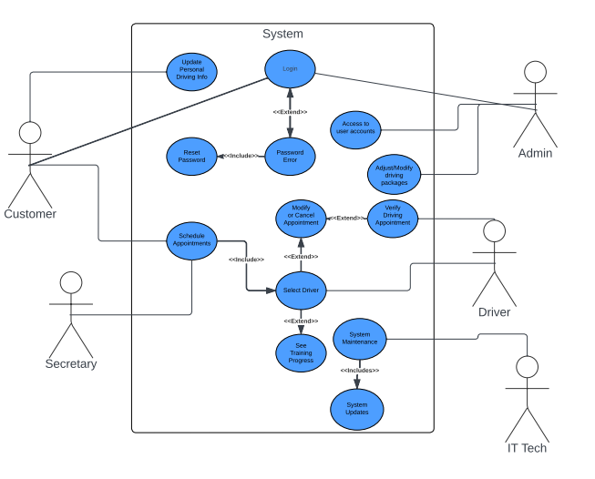

### UML Activity Diagrams

### UML Sequence Diagram

### UML Class Diagram

## Technical Requirements

* *The web-based application can use servers for hosting which will include cloud servers for storage use*
* *Must have a device with browser capabilities to connect to application*
* *Secure payment service to protect customer payment method*
* *Secure browser connection to protect customer information*
* *Scheduling system to administer appointments*
* *Third party authentication process to secure user accounts*